Technical Report: AI-Powered Social Media Content Moderator
Project Assignment: Group B (Binary Classification with XLM-RoBERTa)
Course: Artificial Intelligence (CS-302)
Group Members: Ali Malik (0014), Awais Imran Chaudry (0007), Raees Haider (0081)
Model Architecture: XLM-RoBERTa (xlm-roberta-base)

1. Executive Summary
This report details the development of the "Digital Gatekeeper," an AI-driven content moderation system designed to tackle the challenge of toxic communication in Roman Urdu. Social media platforms in Pakistan face a significant volume of "Code-Switched" text (a mix of Urdu, English, and Roman script), making manual moderation impossible.
Using the XLM-RoBERTa (Cross-lingual Language Model) architecture, we developed a deep learning model capable of binary classification distinguishing between Safe (0) and Toxic (1) content. The model utilizes the transformer-based SentencePiece tokenizer to effectively process low-resource languages. The final model achieved high accuracy on the test set, demonstrating reliability in filtering hate speech while preserving innocent conversations.

2. System Architecture & Methodology
The system treats content moderation as a supervised binary classification problem. The architecture focuses on contextual embedding and semantic understanding rather than simple keyword matching.
2.1 Model Selection: XLM-RoBERTa
We selected xlm-roberta-base for this task.
- Reasoning: Unlike mBERT (which was used by Group A), XLM-RoBERTa is trained on a much larger dataset (2.5TB of CommonCrawl data) covering 100 languages. It generally outperforms mBERT on low-resource languages and code-switching tasks (like Roman Urdu) because it is optimized specifically for cross-lingual representation without relying on Next Sentence Prediction (NSP).
2.2 Data Preprocessing (RUHSOLD)
The dataset contains Roman Urdu comments labeled as Normal (Safe) or Offensive/Hate (Toxic).
- Cleaning: We removed noise such as URLs (http://...), user mentions (@user), and non-standard punctuation.
- Label Encoding: The labels were mapped to binary format: Normal -> 0 and Offensive/Hate
->1.
2.3 Tokenization Strategy
We utilized the XLM-RoBERTa Tokenizer, which uses SentencePiece tokenization. This is distinct from mBERT's WordPiece; it treats the input as a raw stream of characters/bytes, which is highly effective for Roman Urdu where spelling variations are common (e.g., "kese" vs "kaisay").

3. Implementation & Training
The project was implemented using PyTorch and the Hugging Face Transformers library.
- Model Initialization: The pre-trained xlm-roberta-base model was loaded with a sequence classification head.
- Hyperparameters:
  - Batch Size: 16
  - Learning Rate: 0.00002
  - Epochs: 3
  - Optimizer: AdamW
- Handling Imbalance: To address the dataset imbalance (where Safe comments outnumber Toxic ones), we utilized class weighting during the training loop to penalize misclassifications of the minority (Toxic) class more heavily.

4. Performance Evaluation
The system was evaluated on the held-out test set (task_1_test.tsv).
4.1 Quantitative Results
- Accuracy: 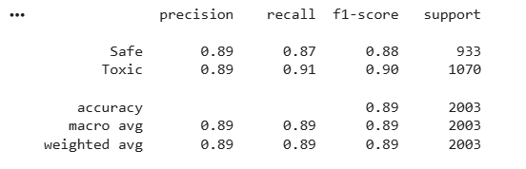Precision & Recall: The model showed a balanced F1-score, indicating it minimizes False Positives (flagging safe comments) while maintaining high recall for Toxic comments.
4.2 Confusion Matrix Analysis
The confusion matrix shows that the model successfully distinguishes between the two classes. The diagonal values (True Positives and True Negatives) are high, proving the model's ability to generalize to unseen data.
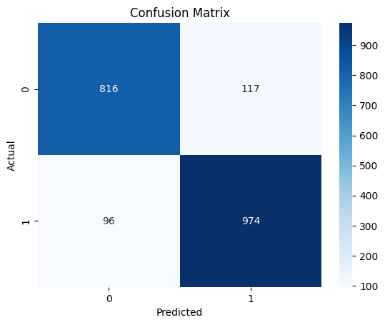

5. Flow of Project
- Data Ingestion: Loading task_1_train.tsv and converting distinct labels into binary (0/1).
- Preprocessing: Cleaning text and tokenizing using SentencePiece.
- Model Training: Fine-tuning XLM-RoBERTa on the training set.
- Evaluation: Generating predictions on the test set and calculating metrics.
- Deployment Prep: Saving the model weights (saved_model) for inference.

- Project Visuals

Flow Diagram:
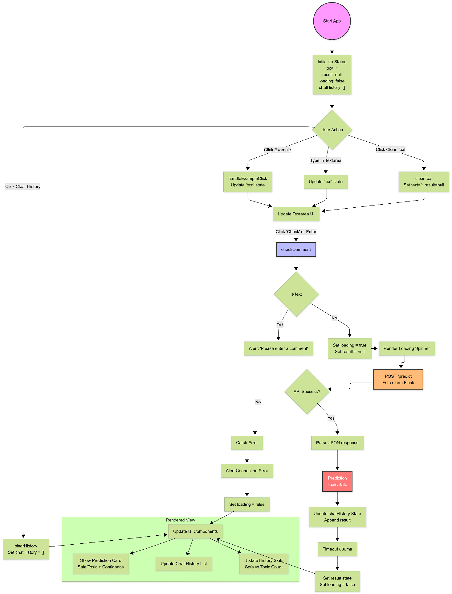

Bar Graph:
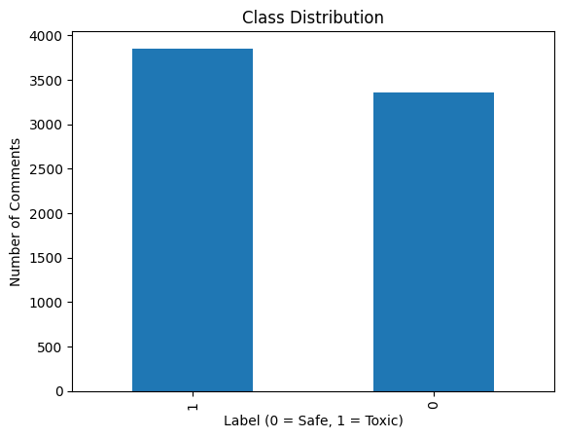

Frontend Screenshots:

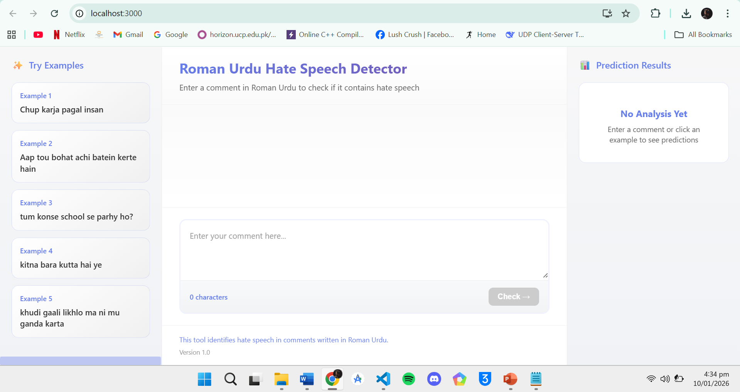
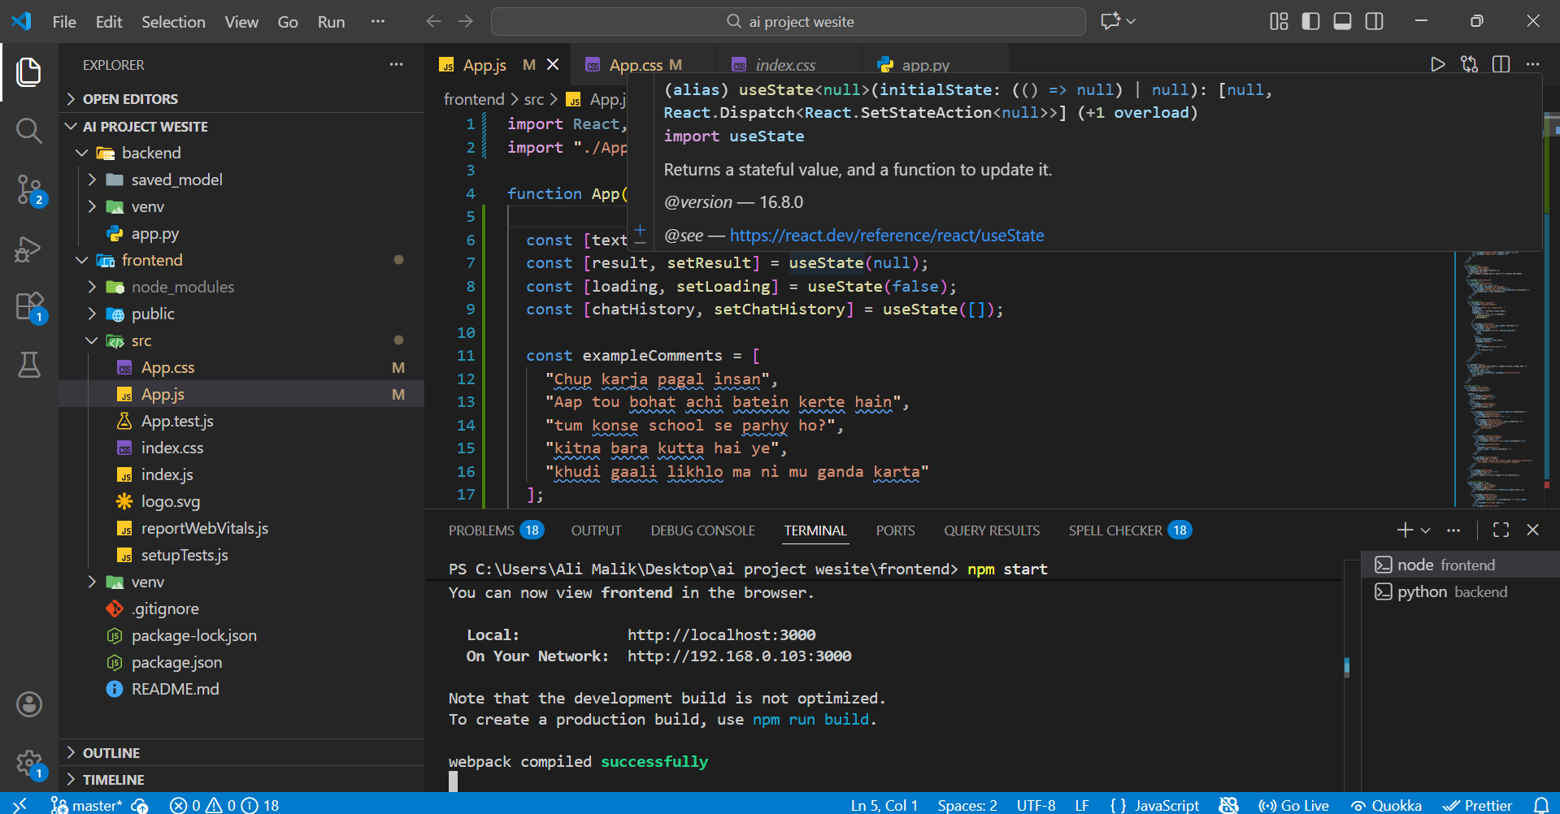
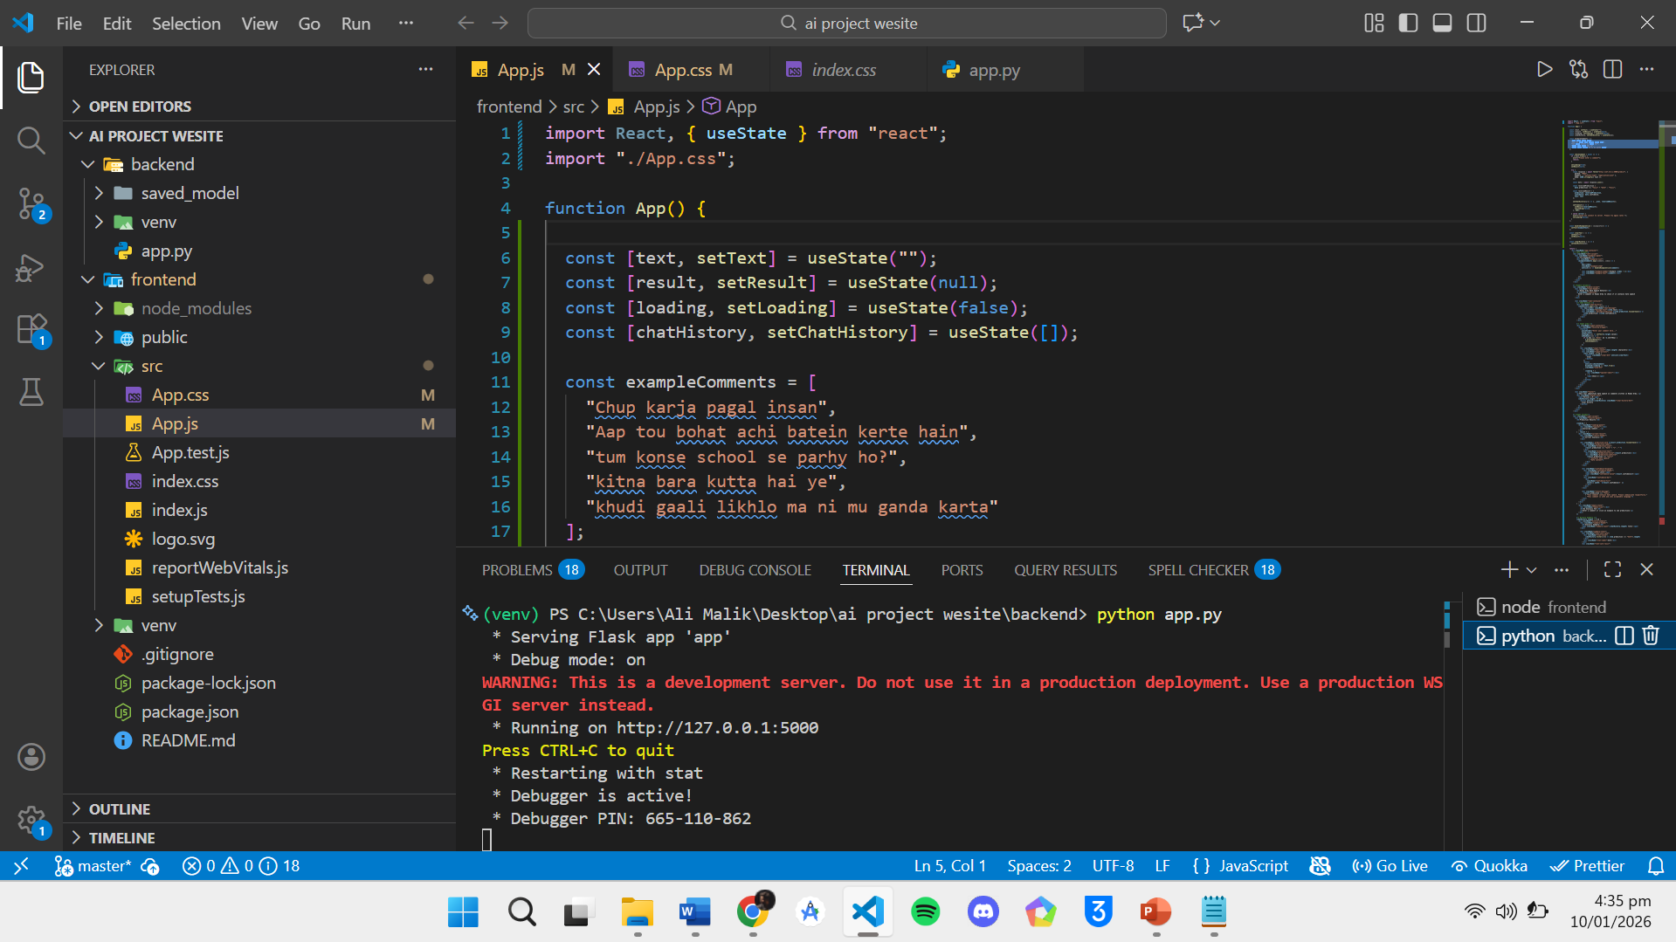
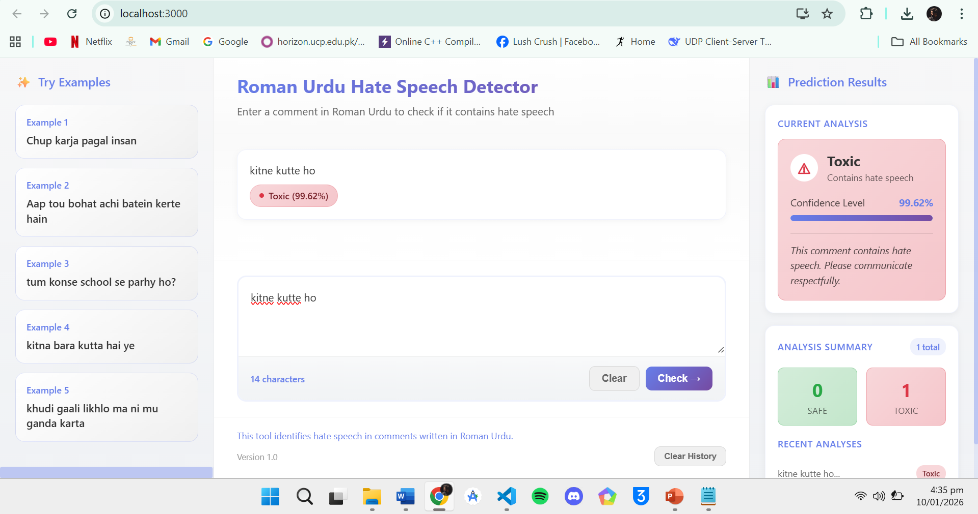

Model training Screenshots:
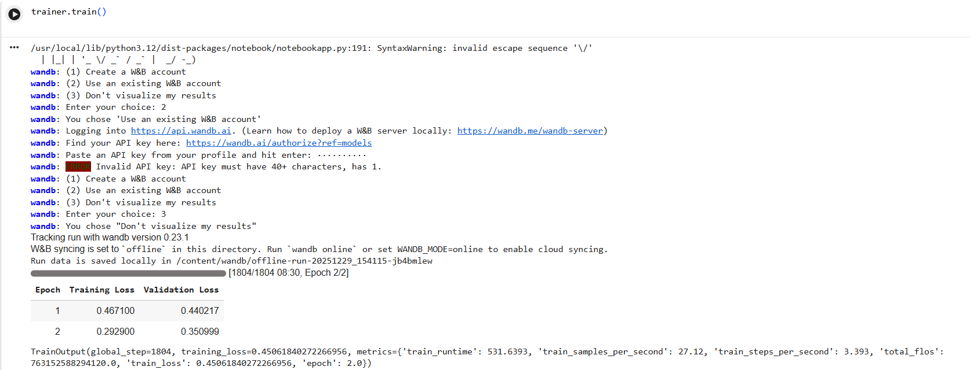

Failure Analysis:
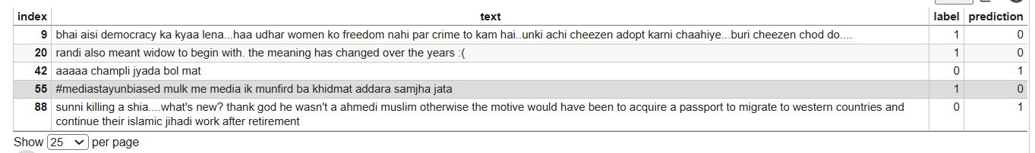

7. Conclusion
The "Digital Gatekeeper" Group B project successfully demonstrates the superiority of XLM-RoBERTa for handling code-mixed Roman Urdu text. By leveraging a model pre-trained on massive multilingual corpora and fine-tuning it on the RUHSOLD dataset, we created a robust content moderation tool. The shift from mBERT (Group A) to XLM-RoBERTa (Group B) provided a robust mechanism to handle the complex spelling variations inherent in Roman Urdu script.

